ECA0304 – SIGNALS AND SYSTEMS
CO2 COMPARATIVE ANALYSIS ASSESSMENT
CHOOSING THE RIGHT FREQUENCY-DOMAIN TOOL
Comparative Analysis of Power, Radar and EV Drive Signals

Submission detail | Information
Course | ECA0304 – Signals and Systems
Course Outcome | CO2 – Fourier and Laplace transform applications
Assessment | Integrated comparative-analysis assignment
Maximum marks | 100
Student name | K. Shalini
Register number | 192512270
Department / Section | B.E.ECE

CONTENTS
- 1. Introduction and Data Pack
- 2. Stage 1 – Compare the Periodic Representations
- 3. Stage 2 – Radar Time-Domain and Frequency-Domain Analysis
- 4. Stage 3 – Parseval Verification and Power Comparison
- 5. Stage 4 – Laplace and Fourier for the EV Motor-Drive Response
- 6. Final Comparative Engineering Decision
- 7. Conclusion
- 8. Appendix – Python Verification Code and Formula Summary

1. INTRODUCTION AND DATA PACK
The assignment compares three engineering situations: a periodic power-system waveform, a short radar pulse with a carrier, and a transient response associated with an electric-vehicle motor drive. Each situation has a different signal characteristic, so the most useful mathematical representation is not necessarily the same.
The objective is to select and justify Fourier series, Fourier transform or Laplace transform according to the signal and engineering question. The work includes analytical derivations, physical interpretation, numerical verification and a final tool-selection workflow.

1.1 Given data
Application | Given information
Power-system waveform | v(t)=120+80cos(ω₀t)+40cos(3ω₀t)−20sin(5ω₀t) V; f₀=50 Hz; T₀=1/f₀.
Radar observation | r(t)=rect(t/20 µs)cos(2π·10 MHz·t); pulse duration 20 µs; carrier frequency 10 MHz.
EV motor-drive | Input u(t); H(s)=10/(s²+4s+20); concern: numerical/floating-point precision.

1.2 Transform selection overview
Tool | Best suited to | Main information obtained
Fourier series | Periodic signals | DC value, harmonic amplitudes/phases and average power.
Fourier transform | Aperiodic finite-energy signals or pulse observations | Continuous frequency spectrum, spectral locations and bandwidth.
Laplace transform | Transient and system-response analysis | Poles, natural modes, damping and stability.

2. STAGE 1 – COMPARE THE PERIODIC REPRESENTATIONS

2.1 Fundamental period and frequency
f₀ = 50 Hz; T₀ = 1/f₀ = 1/50 = 0.02 s = 20ms
ω₀ = 2πf₀ = 100π rad/s ≈ 314.159 rad/s
The waveform contains a DC component and sinusoidal components at the fundamental, third and fifth harmonics. The harmonic frequency is fₙ= n f₀.

2.2 Symmetry observations
The DC term is constant and does not oscillate. The cosine terms are even functions of time, while the sine term is odd. Because the waveform contains both cosine and sine components together with a DC offset, the complete waveform is neither purely even nor purely odd.
- The cosine components contribute cosine Fourier coefficients.
- The sine component contributes a sine Fourier coefficient.
- No unsupported even/odd symmetry shortcut should be used to remove terms from the complete waveform.
The coefficients can be read directly from the supplied expression because it is already written in trigonometric Fourier-series form.

2.3 Trigonometric Fourier-series coefficients
Use the convention:
v(t)=a₀/2 + Σₙ₌₁∞[aₙcos(nω₀t)+bₙsin(nω₀t)]
Comparing with v(t)=120+80cos(ω₀t)+40cos(3ω₀t)−20sin(5ω₀t):
a₀/2=120 ⇒ a₀=240
a₁=80, a₃=40, b₅=−20
All other aₙ and bₙ coefficients are zero. The non-zero terms are therefore DC, first harmonic cosine, third harmonic cosine and fifth harmonic sine.

2.4 Exponential Fourier-series form
The exponential form is:
v(t)=Σₙ₌₋∞∞ Cₙe^(jnω₀t)
The conversion relations are C₀=a₀/2, Cₙ=(aₙ−jbₙ)/2 for n>0, and C₋ₙ=(aₙ+jbₙ)/2.
For the first harmonic: C₁=C₋₁=80/2=40. For the third harmonic: C₃=C₋₃=40/2=20. For the fifth harmonic, a₅=0 and b₅=−20, so C₅=10j and C₋₅=−10j.
C₀=120; C±1=40; C±3=20; C₅=10j; C₋₅=−10j

2.5 Comparative Fourier-series and harmonic table
Component | Trig. coefficient | Exponential coefficient | Frequency | Physical interpretation
DC | a₀/2=120 V | C₀=120 | 0 Hz | Average or offset voltage.
1st harmonic | a₁=80 V; b₁=0 | C₁=C₋₁=40 | 50 Hz | Fundamental-frequency component.
3rd harmonic | a₃=40 V; b₃=0 | C₃=C₋₃=20 | 150 Hz | Third harmonic; may contribute to waveform distortion.
5th harmonic | a₅=0; b₅=−20 V | C₅=10j; C₋₅=−10j | 250 Hz | Fifth harmonic with sine phase.

2.6 Trigonometric versus exponential form
Representation | Advantages | Limitations / interpretation
Trigonometric | Directly shows cosine and sine amplitudes; convenient for reading the waveform terms and their phase type. | Positive and negative frequency components are not shown explicitly.
Exponential | Compact complex form; clearly represents positive and negative frequency lines and is convenient for transform properties and system analysis. | Complex coefficients may be less intuitive when interpreting real voltage waveforms.

2.7 Physical frequencies and engineering meaning
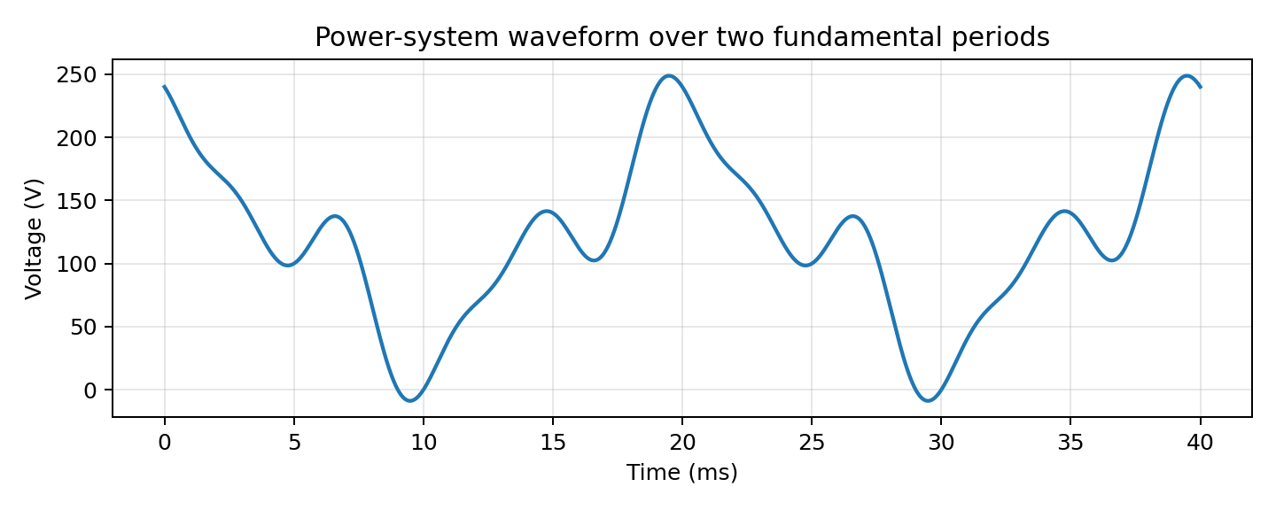
Figure 1. Given power-system waveform plotted over two fundamental periods.
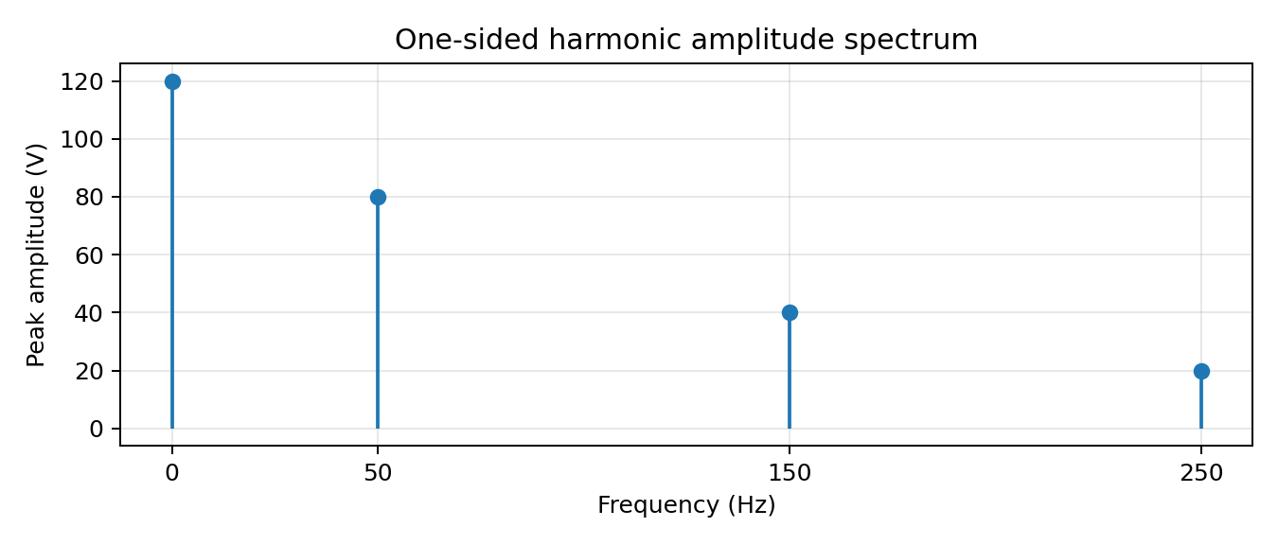
Figure 2. One-sided harmonic amplitude spectrum. The DC component is shown at 0 Hz.
A power-system engineer can use the spectrum to identify which frequencies are present and compare their amplitudes. The 50 Hz fundamental is the largest AC component (80 V peak), followed by the 150 Hz third harmonic (40 V peak) and the 250 Hz fifth harmonic (20 V peak). The harmonic components may be examined for distortion, equipment heating, resonance or filtering requirements. The supplied assignment does not provide an allowable distortion limit, so compliance cannot be concluded from amplitude values alone.

3. STAGE 2 – RADAR TIME-DOMAIN AND FREQUENCY-DOMAIN ANALYSIS

3.1 Time-domain characteristics
The radar observation is:
r(t)=rect(t/T)cos(2πfct), T=20 µs, fc=10 MHz
Using the standard centred rectangular-pulse convention, rect(t/T)=1 for |t|<T/2 and zero outside the pulse. Therefore, the radar waveform is a 10 MHz cosine present only over a 20 µs interval centred at t=0.
Pulse interval: −10 µs < t < +10 µs
Number of carrier cycles = fcT = 10×10⁶ × 20×10⁻⁶ = 200 cycles
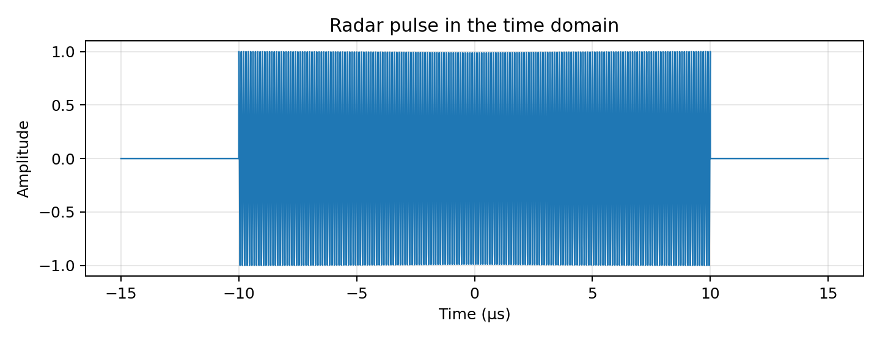
Figure 3. Radar pulse in the time domain, showing the finite observation window and carrier oscillations.

3.2 Fourier-transform derivation
Adopt the Fourier-transform convention X(f)=∫₋∞∞x(t)e^(−j2πft)dt and the normalized sinc function sinc(x)=sin(πx)/(πx).
First define the rectangular window p(t)=rect(t/T). Its Fourier transform is:
P(f)=T sinc(fT)
The carrier can be written using Euler's identity:
cos(2πfct)=½[e^(j2πfct)+e^(−j2πfct)]
Multiplication by a cosine in time produces two shifted copies of the window spectrum in frequency. Applying the modulation/frequency-shifting property:
R(f)=½[P(f−fc)+P(f+fc)]
R(f)=(T/2)[sinc(T(f−fc))+sinc(T(f+fc))]
Substituting T=20 µs and fc=10 MHz gives:
R(f)=10 µs·[sinc(20 µs(f−10 MHz))+sinc(20 µs(f+10 MHz))]

3.3 Main spectral locations and pulse-duration effect
- The two sinc-shaped spectral lobes are centred at +10 MHz and −10 MHz.
- Each sinc envelope has its central peak at the carrier centre.
- The first zeros around the positive-frequency lobe occur at fc±1/T = 10 MHz ± 50 kHz.
- The first zeros around the negative-frequency lobe occur at −10 MHz ± 50 kHz.
- The rectangular time window creates a sinc-shaped spectrum. A shorter pulse has a wider spectrum; a longer pulse has a narrower spectrum.
The first-null-to-first-null width around each lobe is 2/T=100 kHz. This is a main-lobe width, not a claim that the ideal rectangular pulse has strictly finite bandwidth; the sinc sidelobes extend indefinitely.
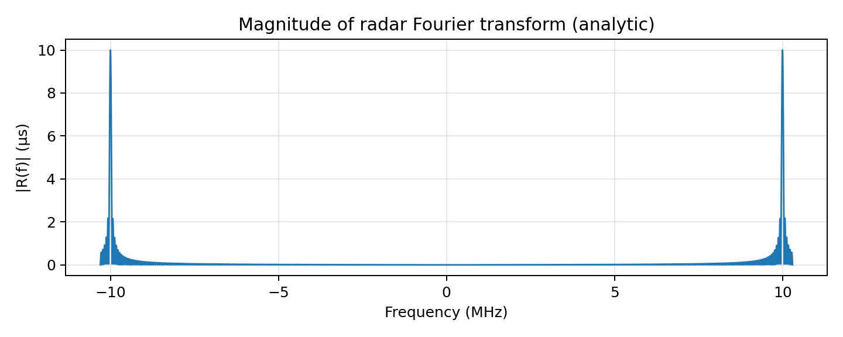
Figure 4. Analytic magnitude spectrum of the radar pulse, showing the two carrier-centred sinc lobes.

3.4 Time-domain versus frequency-domain comparison
Engineering information | Time-domain view | Frequency-domain view
Pulse timing | Directly shows start time, end time and pulse duration. | Timing is not as visually direct; a phase slope may encode delay.
Carrier cycles | Shows the oscillations within the pulse. | Shows the spectral centres at ±10 MHz.
Occupied frequency content | Requires additional analysis or a spectrum calculation. | Directly shows lobe locations, nulls and sidelobes.
Pulse duration / bandwidth trade-off | Duration is directly measurable. | Sinc width demonstrates inverse relation between duration and spectral width.
Amplitude over time | Shows instantaneous waveform amplitude. | Shows how signal content is distributed across frequency.

3.5 Preferred representation
When the engineering objective is to inspect occupied frequency content, the frequency-domain Fourier-transform representation is preferred because it directly identifies the carrier-centred lobes, main-lobe width, null spacing and sidelobes. The time-domain plot remains useful for pulse timing, duration and carrier-cycle counting. Both views are complementary rather than interchangeable.

4. STAGE 3 – PARSEVAL VERIFICATION AND POWER COMPARISON

4.1 Average power from the Fourier-series coefficients
For the trigonometric series v(t)=a₀/2+Σ[aₙcos(nω₀t)+bₙsin(nω₀t)], Parseval's relation gives the average squared value:
P̄v = (a₀/2)² + ½Σₙ₌₁∞(aₙ²+bₙ²)
Using the non-zero coefficients:
P̄v = 120² + ½(80²+40²+(−20)²)
P̄v = 14400 + ½(6400+1600+400)
P̄v = 14400 + 4200 = 18600 V²
This is mean-square voltage. If the waveform is applied across a 1 Ω resistor, the corresponding average power is 18,600 W. The power-system data pack does not specify a load resistance, so the primary result is 18,600 V².

4.2 Independent Parseval check using exponential coefficients
For the exponential Fourier series, Parseval's relation is:
P̄v = Σₙ₌₋∞∞ |Cₙ|²
The non-zero coefficients are C₀=120, C±1=40, C±3=20, C₅=10j and C₋₅=−10j.
P̄v = |120|² + 2|40|² + 2|20|² + |10j|² + |−10j|²
P̄v = 14400 + 3200 + 800 + 100 + 100 = 18600 V²
The trigonometric and exponential forms give the same result. This independently verifies the coefficient-based average-square calculation.

4.3 DC and harmonic contributions
Component | Mean-square contribution | Percentage of total
DC component | 120² = 14,400 V² | 77.42%
1st harmonic | 80²/2 = 3,200 V² | 17.20%
3rd harmonic | 40²/2 = 800 V² | 4.30%
5th harmonic | 20²/2 = 200 V² | 1.08%
Total | 18,600 V² | 100%

The DC component contributes the largest share of the mean-square value. The fundamental is the largest AC contribution. The third and fifth harmonics contribute smaller but non-zero amounts.

4.4 Radar pulse energy and power interpretation
The radar pulse is time-limited, so its total energy is finite. With a unit-amplitude rectangular window and a 10 MHz cosine:
Eᵣ = ∫₋T/2ᵀ/2 cos²(2πfct)dt
The pulse contains exactly 200 carrier cycles. Over an integer number of cycles, the average of cos² is 1/2. Therefore:
Eᵣ = T/2 = 20 µs/2 = 10 µs = 1.0×10⁻⁵ amplitude²·s
The radar pulse is a finite-energy, aperiodic signal, and its infinite-time average power is zero. In contrast, the power-system waveform is periodic and continues indefinitely, so it has finite non-zero average power and infinite total energy over infinite time. This is why the periodic waveform is naturally analysed using Fourier series and average power, while the radar pulse is naturally analysed using the Fourier transform and energy spectrum.

4.5 Effect of increasing or suppressing a harmonic
For a sinusoidal harmonic with peak amplitude Aₙ, its mean-square contribution is Aₙ²/2. If its amplitude is multiplied by a factor k, its contribution becomes k²Aₙ²/2. Thus, increasing a harmonic increases its mean-square contribution quadratically; suppressing it reduces that contribution quadratically.
For example, if the fifth-harmonic amplitude is reduced from 20 V to 10 V, its contribution changes from 20²/2=200 V² to 10²/2=50 V². The total mean-square value decreases by 150 V², from 18,600 V² to 18,450 V². The fifth-harmonic spectral line also becomes half its original amplitude.

4.6 Numerical verification
The waveform can be sampled densely over one fundamental period and its mean square estimated using the sample average. This numerical result should approach the analytical Parseval value as the sample count increases. A 200,000-point calculation gives a value close to 18,600 V²; small differences can arise from finite sampling and floating-point arithmetic.
Method | Mean-square result
Trigonometric Parseval | 18,600 V²
Exponential Parseval | 18,600 V²
Dense numerical time-domain average | Approximately 18,600 V²

The agreement confirms that the harmonic coefficients correctly represent the supplied waveform and that the average-square calculation is consistent in both time and frequency descriptions.

5. STAGE 4 – LAPLACE AND FOURIER FOR THE EV MOTOR-DRIVE RESPONSE

5.1 Transfer function and poles
The given EV motor-drive model is:
H(s)=10/(s²+4s+20)
The poles are the roots of the denominator:
s²+4s+20=0
s=[−4±√(16−80)]/2 = [−4±j8]/2
s₁=−2+j4; s₂=−2−j4
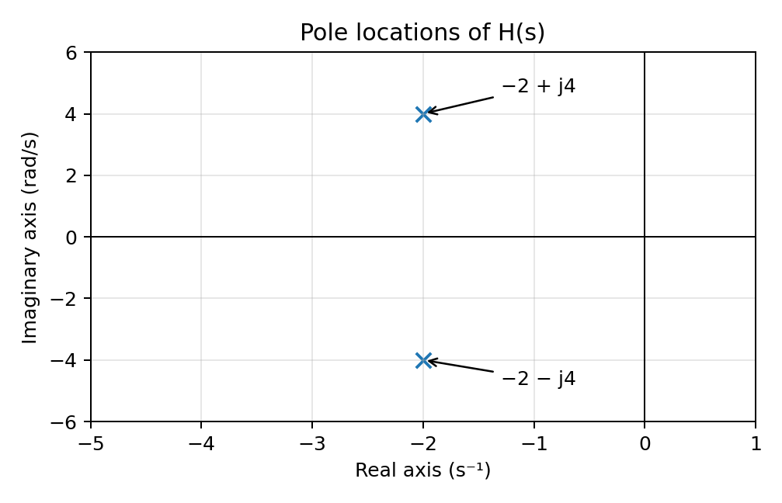
Figure 5. Pole locations. Both poles lie in the left half of the s-plane.
Both poles have negative real parts. For this continuous-time, linear time-invariant model, the natural response decays with time, so the system is asymptotically stable.

5.2 Natural frequency and damping ratio
Compare the denominator with the standard second-order form:
s²+2ζωₙs+ωₙ²
ωₙ²=20 ⇒ ωₙ=√20≈4.472 rad/s
2ζωₙ=4 ⇒ ζ=4/(2√20) = 1/√5≈0.4472
ωd =ωₙ√(1−ζ²) = 4 rad/s
Because 0<ζ<1, the system is underdamped. Its transient response contains decaying oscillations. The exponential decay envelope is e^(−2t), and the damped oscillation frequency is ωd=4 rad/s.

5.3 Unit-step response
The input is u(t), whose Laplace transform is 1/s. Therefore:
Y(s)=H(s)·(1/s)=10/[s(s²+4s+20)]
Using partial fractions:
Y(s)=0.5/s + (−0.5s−2)/(s²+4s+20)
Since s²+4s+20=(s+2)²+16, rewrite the numerator in terms of (s+2):
Y(s)=0.5/s − 0.5(s+2)/[(s+2)²+16] − 1/[(s+2)²+16]
Taking the inverse Laplace transform term by term gives 0.5u(t) − 0.5e^(−2t)cos(4t)u(t) − 0.25e^(−2t)sin(4t)u(t).
y(t)=0.5[1−e^(−2t)(cos(4t)+0.5sin(4t))]u(t)
The final value is 0.5, consistent with the DC gain H(0)=10/20=0.5. The response approaches this value with decaying oscillations.
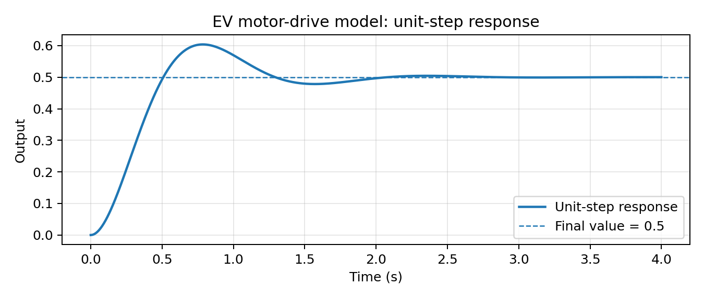
Figure 6. Unit-step response of the EV motor-drive transfer-function model.

5.4 Why Laplace is more informative for transient and stability analysis
Fourier series is intended for periodic signals and expresses them as harmonics. The EV motor-drive question concerns a transient response and system stability, so a Fourier-series representation is not the natural tool. The Laplace transform represents transient modes through the complex variable s and exposes poles directly.
- Pole real parts indicate whether natural modes decay, remain constant or grow.
- Pole imaginary parts indicate oscillatory behaviour and oscillation frequency.
- The pole pair gives the damping ratio and natural frequency.
- The transfer function also supports input-output response calculations through Y(s)=H(s)X(s).

5.5 Pole information versus frequency-response information
Pole / Laplace view | Frequency-response magnitude and phase view
Directly identifies poles at −2±j4. | Shows gain and phase as functions of sinusoidal input frequency.
Negative real parts establish stable decaying natural modes for this model. | Shows resonant or frequency-sensitive behaviour and phase lag.
Gives natural frequency, damping ratio and damped oscillation frequency. | Shows how strongly different sinusoidal frequencies are transmitted.
Well suited to initial-condition and transient-response analysis. | Well suited to steady-state sinusoidal response and bandwidth analysis.

For completeness, substituting s=jω gives:
|H(jω)|=10/√[(20−ω²)²+(4ω)²]
∠H(jω)=−atan2(4ω,20−ω²)
The magnitude/phase response complements the pole analysis but does not replace the direct pole-based explanation of natural transient modes.

5.6 Floating-point precision and verification
Digital implementations store numbers with finite precision. Under IEEE Std 754-2019 floating-point arithmetic, many real values are represented approximately. Rounding can affect computed polynomial coefficients, intermediate arithmetic and numerical root estimates. For a well-conditioned calculation the effect may be very small, but roots can be more sensitive when poles are close together or the polynomial is poorly conditioned.
- Use adequate numeric precision and avoid unnecessary rounding of coefficients during intermediate calculations.
- Compute the poles using a reliable numerical root routine and retain sufficient significant digits.
- Verify the result by substituting each computed pole into s²+4s+20 and checking that the residual is close to zero.
- Compare numerical poles with the analytical values −2±j4 and check that both real parts remain negative.

5.7 Transform-selection decision matrix
Application | Signal characteristic | Best mathematical tool | Evidence | Engineering reason
Power system | Periodic waveform with DC and discrete harmonics. | Fourier series | Fundamental 50 Hz; non-zero components at 0, 50, 150 and 250 Hz; Parseval gives 18,600 V². | Directly provides harmonic amplitudes, phases and average power.
Radar | Finite-duration aperiodic pulse multiplied by a carrier. | Fourier transform | Spectrum is two shifted sinc lobes centred at ±10 MHz; first nulls are 50 kHz from each centre. | Shows frequency occupancy, main-lobe width and sidelobes.
EV motor drive | Transient system response with possible decaying oscillation. | Laplace transform | Poles at −2±j4; ζ≈0.4472 and ωₙ≈4.472 rad/s. | Reveals natural modes, damping, transient response and stability.

6. FINAL COMPARATIVE ENGINEERING DECISION
DECISION: NO – the same transform should not be used for all three applications.
The three applications contain different signal characteristics and require different mathematical information. The power waveform is periodic and contains identifiable harmonics, the radar observation is a finite-duration pulse whose frequency occupancy is important, and the EV motor-drive model is a transient system for which poles and stability must be evaluated.

6.1 Minimum three-route analysis workflow
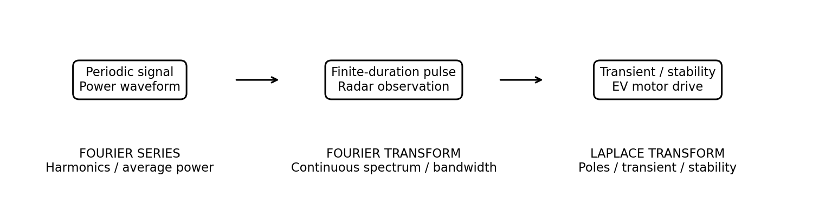
Figure 7. Three-route workflow for selecting the transform according to the engineering application.
Route | When to select | Advantage | Limitation
Fourier series | Periodic power-system waveform and harmonic measurements. | Directly identifies harmonic components and supports average-power calculations. | Not the most natural representation for a single non-periodic radar pulse or transient initial-condition analysis.
Fourier transform | Finite-duration radar pulse and continuous frequency-spectrum inspection. | Shows carrier-centred spectral lobes, bandwidth-related features and sidelobes. | Does not by itself provide the clearest pole-based stability interpretation of a dynamic system.
Laplace transform | EV motor-drive transient response and stability analysis. | Provides poles, damping, natural modes and input-output transient response. | Requires a system model and may involve algebra/numerical computation; it is not a substitute for a periodic harmonic spectrum.

6.2 Engineering recommendation
Standardize the decision process, not one transform. The engineering team should first classify the signal and identify the required engineering question. Then it should select Fourier series for periodic harmonic analysis, Fourier transform for aperiodic pulse-spectrum analysis, and Laplace transform for transient and stability analysis. This application-based workflow avoids using a mathematically valid but less informative tool for the problem at hand.

7. CONCLUSION
The power-system waveform was represented by a trigonometric and exponential Fourier series. Its non-zero frequencies are DC, 50 Hz, 150 Hz and 250 Hz. The average squared voltage calculated using Parseval's relation is 18,600 V².
The radar observation is a finite-duration 10 MHz cosine pulse. Its Fourier transform consists of two sinc-shaped lobes centred at ±10 MHz, with first nulls 50 kHz from each lobe centre. The time-domain representation is best for pulse timing, while the frequency-domain representation is best for occupied spectral content.
The EV motor-drive model has poles at −2±j4, natural frequency approximately 4.472 rad/s, damping ratio approximately 0.4472 and damped frequency 4 rad/s. The left-half-plane poles indicate a stable, underdamped response.
Therefore, one transform should not be imposed on all three applications. A three-route workflow using Fourier series, Fourier transform and Laplace transform is the most suitable engineering recommendation.

8. APPENDIX – PYTHON VERIFICATION CODE AND FORMULA SUMMARY
The following Python code numerically verifies the average-square value of the periodic power waveform, calculates the radar pulse energy, and checks the motor-drive poles. It uses only NumPy.
import numpy as np
# 1. Power-system waveform: numerical Parseval check
f0 = 50
w0 = 2*np.pi*f0
T0 = 1/f0
t = np.linspace(0, T0, 200000, endpoint=False)
v = (120
+ 80*np.cos(w0*t)
+ 40*np.cos(3*w0*t)
- 20*np.sin(5*w0*t))
P_numeric = np.mean(v**2)
P_analytical = 120**2 + 0.5*(80**2 + 40**2 + 20**2)
print("Numerical mean-square voltage:", P_numeric)
print("Parseval result:", P_analytical)
# 2. Radar pulse energy
T = 20e-6
fc = 10e6
tr = np.linspace(-T/2, T/2, 400001)
r = np.cos(2*np.pi*fc*tr)
E_numeric = np.trapz(r**2, tr)
E_analytical = T/2
print("Numerical radar energy:", E_numeric)
print("Analytical radar energy:", E_analytical)
# 3. EV motor-drive poles
poles = np.roots([1, 4, 20])
wn = np.sqrt(20)
zeta = 4/(2*wn)
wd = wn*np.sqrt(1-zeta**2)
print("Poles:", poles)
print("Natural frequency:", wn)
print("Damping ratio:", zeta)
print("Damped frequency:", wd)

8.1 Key results summary
Quantity | Final result
Fundamental period | T₀=0.02 s = 20 ms
Fundamental angular frequency | ω₀=100π rad/s ≈ 314.159 rad/s
Non-zero harmonic frequencies | 0 Hz, 50 Hz, 150 Hz, 250 Hz
Trigonometric coefficients | a₀=240; a₁=80; a₃=40; b₅=−20
Exponential coefficients | C₀=120; C±1=40; C±3=20; C₅=10j; C₋₅=−10j
Power waveform mean-square | 18,600 V²
Radar transform | R(f)=(T/2)[sinc(T(f−fc))+sinc(T(f+fc))]
Radar energy | 1.0×10⁻⁵ amplitude²·s
EV poles | −2±j4
EV natural frequency | ωₙ≈4.472 rad/s
EV damping ratio | ζ≈0.4472
EV damped frequency | ωd=4 rad/s
Final decision | NO – use a three-route transform-selection workflow.

8.2 Assumptions and scope notes
- The rectangular pulse uses the standard centred definition rect(t/T)=1 for |t|<T/2 and zero outside; endpoint values do not affect the transform.
- The Fourier transform is defined with frequency f in hertz and kernel e^(−j2πft); sinc(x)=sin(πx)/(πx).
- The radar energy assumes unit amplitude and no load resistance is specified; it is stated in amplitude-squared seconds.
- The power-system result is mean-square voltage. Conversion to watts requires a load resistance; 1 Ω is not given for this CO2 assignment.
- The power waveform's overall symmetry is neither purely even nor purely odd.
- The step-response formula is for the given transfer function with zero initial conditions and unit-step input.
- Numerical plots are illustrative visualizations of the exact supplied models; numerical results should be interpreted with the stated assumptions.

